CO2-AT1
Name: B.Praneeth Reg no:192472222
Introduction
Morphological analysis is the process of decomposing words into meaningful components such as roots, prefixes, and suffixes. It is useful in natural language processing applications including document indexing, sentiment analysis, search engines, text processing, and information retrieval. This report presents five rule-based problems covering morphological decomposition, derivational and inflectional analysis, stemming, finite-state parsing, and Porter stemming.
Problem 1 – Morphological Analysis Pipeline
Input words: connected, connecting, connection.
The objective is to decompose each word into its root and suffix, classify the suffix as inflectional or derivational, and normalize all related forms to a common base.
Word | Root | Suffix | Type | Normalized
connected | connect | ed | Inflectional | connect
connecting | connect | ing | Inflectional | connect
connection | connect | ion | Derivational | connect
Rules:
- -ed indicates past tense and is inflectional.
- -ing indicates progressive form and is inflectional.
- -ion forms a noun from a verb and is derivational.
Python Program:
words = ["connected", "connecting", "connection"]
def analyze_word(word):
if word.endswith("ing"):
root = word[:-3]
suffix = "ing"
suffix_type = "Inflectional"

elif word.endswith("ed"):
root = word[:-2]
suffix = "ed"
suffix_type = "Inflectional"
elif word.endswith("ion"):
root = word[:-3]
suffix = "ion"
suffix_type = "Derivational"
else:
root = word
suffix = "-"
suffix_type = "None"
return root, suffix, suffix_type
print("\nMORPHOLOGICAL ANALYSIS")
print("-" * 75)
print(f"{'Word':<15}{'Root':<15}{'Suffix':<12}{'Type':<18}{'Normalized':<15}")
print("-" * 75)
for word in words:
root, suffix, suffix_type = analyze_word(word)
print(f"{word:<15}{root:<15}{suffix:<12}"
f"{suffix_type:<18}{root:<15}")
Output
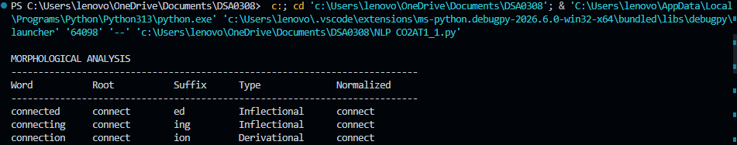
Interpretation: All three forms are normalized to connect, allowing related forms to be retrieved together.

Problem 2 – Morphological Parsing for Sentiment Analysis
Input words: unhappy, happiness, happily.
Word | Prefix | Root/Base | Suffix | Type | Normalized
unhappy | un | happy | - | Derivational | happy
happiness | - | happy | ness | Derivational | happy
happily | - | happy | ly | Derivational | happy

Python Program:
words = ["unhappy", "happiness", "happily"]
def morphological_parse(word):
if word.startswith("un"):
prefix = "un"
root = word[2:]
suffix = "-"
transformation = "Derivational"
elif word.endswith("ness"):
prefix = "-"
root = word[:-4]
suffix = "ness"
transformation = "Derivational"
elif word.endswith("ly"):
prefix = "-"
root = word[:-2]
suffix = "ly"
transformation = "Derivational"
else:
prefix = "-"
root = word
suffix = "-"
transformation = "None"
return prefix, root, suffix, transformation
print("\nMORPHOLOGICAL PARSING")
print("-" * 85)
print(f"{'Word':<15}{'Prefix':<12}{'Root':<15}"
f"{'Suffix':<12}{'Type':<20}{'Normalized':<15}")
print("-" * 85)
for word in words:
prefix, root, suffix, transformation = morphological_parse(word)
print(f"{word:<15}{prefix:<12}{root:<15}"
f"{suffix:<12}{transformation:<20}{root:<15}")
Output:
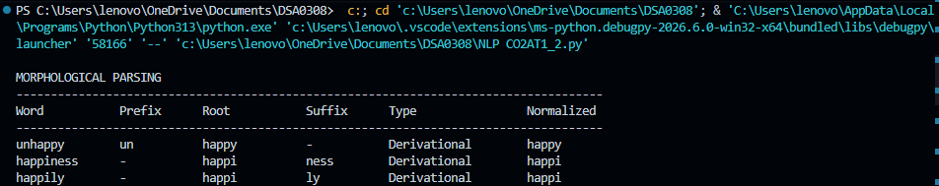
Interpretation: The common semantic root is happy. Normalization helps sentiment systems treat related derived forms consistently.
Problem 3 – Stemming-Based Search Engine Module
Input words: played, player, playing.
Original | Stem | Removed Affix | Transformation | Normalized
played | play | ed | Inflectional | play
player | play | er | Derivational | play
playing | play | ing | Inflectional | play

Python Program:
words = ["played", "player", "playing"]
def stem_word(word):
if word.endswith("ing"):
stem = word[:-3]
affix = "ing"
transformation = "Inflectional"
elif word.endswith("ed"):
stem = word[:-2]
affix = "ed"
transformation = "Inflectional"
elif word.endswith("er"):
stem = word[:-2]
affix = "er"
transformation = "Derivational"
else:
stem = word
affix = "-"
transformation = "None"
return stem, affix, transformation
print("\nSTEMMING ANALYSIS")
print("-" * 85)
print(f"{'Original':<15}{'Stem':<15}{'Affix':<12}"
f"{'Transformation':<20}{'Normalized':<15}")
print("-" * 85)
for word in words:
stem, affix, transformation = stem_word(word)
print(f"{word:<15}{stem:<15}{affix:<12}"
f"{transformation:<20}{stem:<15}")

Output:
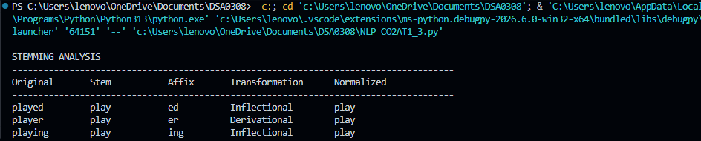
Interpretation: played, player, and playing are normalized to play, improving matching in search and information retrieval.

Problem 4 – Finite-State Morphological Parsing
Input words: writes, writing, written.
Finite-state model:
START → ROOT → AFFIX → ACCEPT
For the irregular form written, an irregular transition is used:
START → ROOT → IRREGULAR → ACCEPT
Word | State Path | Morphology | Root | Pattern | Normalized
writes | q0 → q1 → q2 → q3 | write + s | write | Regular Inflection | write
writing | q0 → q1 → q2 → q3 | write + ing | write | Regular Inflection | write
written | q0 → q1 → q_irregular → q3 | write → written | write | Irregular Inflection | write

Python Program:
words = ["writes", "writing", "written"]
def finite_state_parser(word):
if word == "writes":
path = ["q0", "q1", "q2", "q3"]
root = "write"
morpheme = "write + s"
pattern = "Regular Inflection"
normalized = "write"
elif word == "writing":
path = ["q0", "q1", "q2", "q3"]
root = "write"
morpheme = "write + ing"
pattern = "Regular Inflection"
normalized = "write"
elif word == "written":
path = ["q0", "q1", "q_irregular", "q3"]
root = "write"
morpheme = "write → written"
pattern = "Irregular Inflection"
normalized = "write"
else:
path = ["q0", "q_reject"]
root = word
morpheme = "-"
pattern = "Unknown"
normalized = word
return path, morpheme, root, pattern, normalized
print("\nFINITE-STATE MORPHOLOGICAL PARSER")
print("-" * 110)
print(f"{'Word':<12}{'State Path':<35}{'Morphology':<20}"
f"{'Root':<12}{'Pattern':<22}{'Normalized':<12}")
print("-" * 110)
for word in words:
path, morpheme, root, pattern, normalized = finite_state_parser(word)
print(f"{word:<12}{' → '.join(path):<35}"
f"{morpheme:<20}{root:<12}"
f"{pattern:<22}{normalized:<12}")
Output:
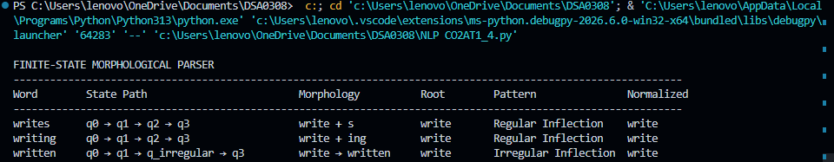
Interpretation: writes and writing follow regular transitions, while written is handled through a special irregular transition. All forms normalize to write.
Problem 5 – Porter Stemmer-Based Preprocessing
Input words: relational, relation, relate.
Original | Step | Rule | Intermediate Form | Final Stem
relational | Step 2 | ATIONAL → ATE | relate | relat
relational | Step 5 | E → ∅ | relat | relat
relation | Step 4 | ION removal | relat | relat
relate | Step 5 | E → ∅ | relat | relat

Python Program:
words = ["relational", "relation", "relate"]
def porter_stem(word):
original = word
steps = []
# Step 2: ational -> ate
if word.endswith("ational"):
word = word[:-6] + "e"
steps.append("ATIONAL -> ATE: " + word)
# Step 2: tional -> tion
elif word.endswith("tional"):
word = word[:-2]
steps.append("TIONAL -> TION: " + word)
# Step 4: remove ion
if word.endswith("ion"):
stem = word[:-3]
if stem.endswith("at"):
word = stem
steps.append("ION removal: " + word)
# Step 5: remove final e
if word.endswith("e") and len(word) > 3:
word = word[:-1]
steps.append("E removal: " + word)
return original, steps, word
print("\nPORTER STEMMER ANALYSIS")
print("-" * 80)
print(f"{'Original':<15}{'Applied Rules':<40}{'Final Stem':<15}")
print("-" * 80)
for word in words:
original, steps, stem = porter_stem(word)
rules = " | ".join(steps)
print(f"{original:<15}{rules:<40}{stem:<15}")

Output:
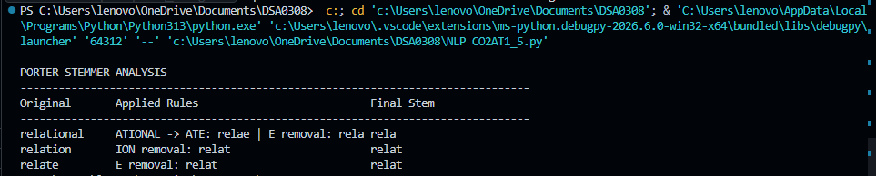
Interpretation: The Porter rules reduce relational, relation, and relate to the computational stem relat.
Final Comparative Summary
Q | Input | Main Method | Classification | Normalized Output
1 | connected, connecting, connection | Morphological decomposition | Inflectional + Derivational | connect
2 | unhappy, happiness, happily | Rule-based parsing | Derivational | happy
3 | played, player, playing | Stemming | Inflectional + Derivational | play
4 | writes, writing, written | Finite-state parsing | Regular + Irregular | write
5 | relational, relation, relate | Porter stemming | Derivational stemming | relat

Key Concepts
- Inflectional morphology: Changes grammatical form without normally creating a new lexical word, e.g., play → played.
- Derivational morphology: Creates a new lexical form or changes meaning/category, e.g., happy → happiness.
- Stemming: Removes affixes to obtain a computational stem, which may not be a complete English word.
- Morphological normalization: Maps related word forms to a common representation for retrieval.
- Finite-state parsing: Uses states and transitions to recognize roots, suffixes, and irregular morphological patterns.
Conclusion
The five problems demonstrate different approaches to morphological processing. Rule-based decomposition identifies roots and affixes, stemming reduces grammatical and derivational variations, finite-state parsing represents morphological transitions, and Porter stemming produces compact computational stems. These methods support efficient document indexing, search, sentiment analysis, and general natural language processing.

